Funding Opportunity Announcement

TSC Alliance Biosample Seed Grants

The TSC Alliance announces a funding opportunity for 2022 Biosample Seed Grants to support research using blood, tissue, and/or cells, DNA, or RNA isolated from samples in the TSC Biosample Repository. The award may support laboratory supplies, personnel costs, services, or equipment necessary to conduct the proposed research. Funds requested can be up to $20,000. Funding period is one year.

The TSC Biosample Repository houses human biological materials linked to detailed clinical data in the TSC Natural History Database. High-quality biosamples and their associated clinical data enable researchers to discover biomarkers, establish human cell lines or tissue arrays for drug testing, and search for clues to understand why TSC is so different from person to person.

As of September 15, 2022, the TSC Biosample Repository has received:
- 384 buccal cell samples for DNA isolation
- 783 blood samples from which plasma and white blood cells have been isolated
- tissue samples
- 161 tissue samples
- 499 blood samples (PREVeNT, RDCRN) and 389 DNA samples (TACERN) from TSC Clinical Research Consortium projects, some of which may be available via application to the projects’ Biosample Use Committee. Please specify in your application if these samples are of interest.
- Please see a detailed inventory here: https://docs.google.com/spreadsheets/d/17FdKgGrWBL2DvP9RbQ-TCOKXU-KlwzC9ecgadKIQyJg/edit#gid=0

Requirements/eligibility
- To build the dataset associated with each biosample and avoid duplication of work in the future, applicants will be required to share data generated on each sample back to the TSC Biosample Repository.
  - Data can be embargoed for a period of time to be defined in the Material Transfer Agreement to provide time to publish, protect intellectual property, etc.
- This opportunity is open to all investigators at established academic or research institutions worldwide.
  - Researchers at start-up pharmaceutical or biotech companies are eligible if they are unable to utilize TSC biosamples in absence of seed funding.
- Researchers residing in the United States need not be U.S. citizens to apply.
- We welcome applications from tenure-track faculty or equivalent, non-tenure-track faculty, and postdoctoral (PhD or MD) fellows.

application components
Compile the following into a single PDF file and email to Gabrielle Rushing, PhD, at grushing@tscalliance.org AND biosample@tscalliance.org no later than 11:00 pm Eastern (US/Canada) on Friday, October 28, 2022.

Required components:
- Complete the Application for Biosample Access located below this FOA. The “Study Information” section may be up to two pages in length to fully explain the rationale, objectives, and experimental design. Preliminary data are encouraged to demonstrate feasibility of the approach. Complete the Natural History Database Data Request Form if applicable located below the Application for Biosample Access.
- Include a “Statement of Impact” up to a half-page in length describing how this seed funding will advance your research. For example, where will this lead if the experiment is successful, or how will these results be used to apply for a larger grant?
- Include a one-page budget and justification for direct costs requested. Limited salary support may be included if required by the institution, but salary support must be strongly justified given the short-term nature of seed funding.
- Principal investigator’s NIH-style biosketch or short CV, not exceeding 5 pages.
- IRB approval letter, exemption letter from an institutional official or department chair, or statement that the project has been submitted to your IRB and is awaiting a decision.

evaluation criteria
Criteria used to evaluate and prioritize applications for seed funding will include, but are not necessarily limited to:
- Relevance to TSC. Biosamples may be used in studies together with samples from individuals with related disorders for the mutual benefit of multiple disorders, including TSC. However, biosamples will not be provided for use as “control” samples in studies primarily focused on other disorders.
- Impact on TSC research and the TSC community.
- Leveraging data from the Natural History Database linked to each biosample to enhance experimental design, interpretation of results, and impact of the study.

funding notice
Successful applicants will be notified by Monday, November 21, 2022.

questions
Please contact Gabrielle Rushing, PhD (grushing@tscalliance.org) with any questions.

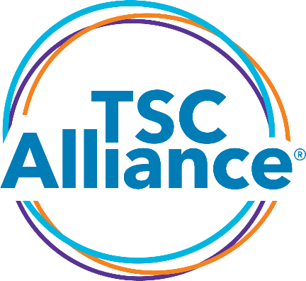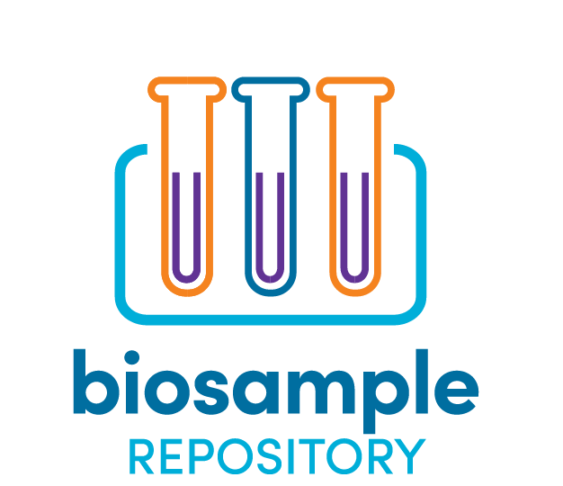

APPLICATION FOR BIOSAMPLE ACCESS:

BSR SEED GRANTS

Data Sharing Statement
Along with the biosamples, you will be entitled to receive any data generated by other investigators using these samples. In return, you are required to share data generated on each sample with the TSC Biosample Repository. Data can be embargoed for a period to be defined in the Material Transfer Agreement to provide time to publish, protect intellectual property, etc. You can describe your data sharing plan in the application below.

☐ Please check here to acknowledge that you have read and understand the data sharing statement.

Application Form

Principal Investigator Information

First Name: | Middle Name: | Last Name:
Salutation: | Degree(s): | Title:
Phone: | Alt. Phone: | Fax:
Email: | CC Email:

Mailing Address

Institution: | Department:
Address Line 1: | Address Line 2:
City: | State: | Zip:
Country: | Institution’s Federal Congressional District:
Funding source(s) to support the proposed work, including specific award numbers:

Date of Request:
PI Demographics (Optional)

This information is optional but is vital to track the TSC Alliance’s progress toward improving the equity, diversity, and inclusion of our research programs. The information will not be disclosed or disseminated to anyone outside of the Steering Committee and the TSC Alliance. The information will not be used to decide whether a specific application is approved or not.

Gender

☐Male ☐Female ☐Prefer not to disclose ☐Prefer to self-describe: Click or tap here to enter text.

Race

☐American Indian or Alaska Native ☐Asian ☐Black or African American

☐Native Hawaiian or Other Pacific Islander ☐White or Caucasian ☐Prefer not to disclose

☐Prefer to self-describe: Click or tap here to enter text.

Ethnicity

☐Hispanic or Latinx ☐Not Hispanic or Latinx ☐Prefer not to disclose

☐Prefer to self-describe: Click or tap here to enter text.

Shipping Information

Lab contact/Recipient:

☐ Check if the same as PI Information

First Name: | Middle Name: | Last Name:
Salutation: | Degree(s): | Title:
Phone: | Alt. Phone: | Fax:
Email: | CC Email:

Shipping Address

☐ Check if the same as PI Information

Institution: | Department:
Address Line 1: | Address Line 2:
City: | State: | Zip:
Country:

Study Information

Study Title:

Specific Aims:

Long-term study objectives (please include potential impact to TSC community):

Overall Project Summary (please include experimental design and methods):

Justification for Numbers:

Example: volume or quantity of samples requested. Please include statistical power analysis, if applicable.

How soon will you use the samples once received?:

Data Sharing - Please describe the specific data elements that will be provided back to the TSC Biosample Repository for each sample analyzed:

Data Sharing – Please describe any other ways you plan to share the data, results, and resources that are generated:

Sample Request Information: Donor Details

Donor Demographics

Biological Sex: ☐ Male ☐ Female ☐ Either

Race: ☐ Any

☐ American Indian or Alaska Native ☐ Asian ☐ Black or African American

☐ Native Hawaiian or Other Pacific Islander ☐ White or Caucasian ☐ Multi-racial

Age Range:

Minimum: Maximum:

Donor Clinical History (please list any inclusion and exclusion requirements):

Total Number of Donors Requested:

Sample Preparation Details
Blood Prep Type
☐ Plasma Volume: ☐mL ☐µL
☐ White Blood Cell Pellets Number of cells per sample: Click or tap here to enter text.

☐ Other (please explain):

Nucleic Acid (please specify source)

☐ DNA from Blood ☐ DNA from Buccal Swabs ☐ DNA from Tissue

Minimum quantity: Maximum quantity:

Minimum concentration: Maximum concentration:

Minimum volume: ☐mL ☐µL

Tissue (select all that apply; please specify tissue origin in ‘Other Preparation Details’ below)

☐ Frozen

☐ FFPE

☐ Tissue Curls Thickness: # of curls:

☐ Glass Slides # of unstained slides: # H&E stained slides:

Other Preparation Details
Please describe, including specifics as appropriate:

Any other considerations we should be aware of?

Natural History Database (NHD) Data
Will your project also use data stored in the NHD?

☐ YES
☐ NO

If YES, please fill out the shortened NHD DATA REQUEST FORM found below.

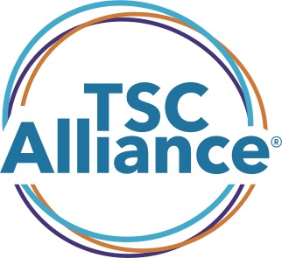
TSC Natural History Database Data Request Form:
BSR SEED GRANTS

Data Variables Requested
Please check all data variables that you are requesting from the NHD for your Biosample Seed Grant Application.

The categories below list example fields in each category. For a full variable list, please reach out to Gabrielle Rushing, PhD, at grushing@tscalliance.org.

*For all data exports, the TSC Alliance exports “age at” specific encounters rather than exporting dates for data privacy. If your project needs dates exported, including date of birth of participant, please check this box and explain below: ☐

Explanation: Click or tap here to enter text.

☐ Cardiovascular
☐ Comorbidities (includes chronic infections, diabetes, autoimmune and more)
☐ COVID-19 Data (applies only to participants with a confirmed positive test)
☐ Demographics (biological sex, race, ethnicity)
☐ Dental
☐ Dermatological
☐ Diagnosis (clinical or molecular)
☐ Family Participation
☐ Genetics
☐ Liver
☐ Mortality
☐ Neurological (epilepsy, SEGA, SENs, tubers and associated treatments)
☐ Additional data on a subset of participants in a subproject including SEGA imaging dates/data, epilepsy surgery, SEGA shunt, and VNS. For full variable list, please contact Gabrielle Rushing, PhD, at grushing@tscalliance.org.
☐ Antiepileptic drugs (“snapshot” – if participant has ever received drug and if it is ongoing)

☐ Neuropsychiatric (intellectual ability, psychiatric disorders, learning disorders, behaviors)
☐ Psychoactive drugs (“snapshot” – if participant has ever received drug and if it is ongoing)

☐ Ophthalmological
☐ Other TSC conditions (non-renal abdominal harmartoma, other TSC-related condition not captured elsewhere)
☐ Perinatal (prenatal history)
☐ Pulmonary
☐ Rare Conditions
☐ Renal (angiomyolipoma, cysts, polycystic kidneys and associated treatments)
☐ Additional data on a subset of participants in a subproject including angiomyolipoma imaging dates/data, nephrectomy, eGFR, and serum creatinine. For full variable list, please contact Gabrielle Rushing, PhD, at grushing@tscalliance.org.

☐ Reproductive

