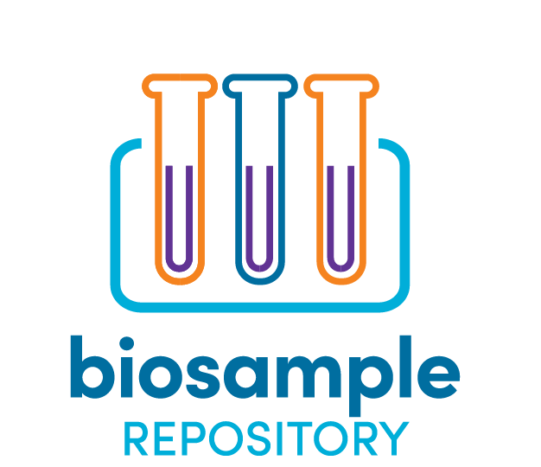

APPLICATION FOR BIOSAMPLE ACCESS

Purpose
Please submit this Application for Biosample Access if you meet both of the following criteria:
- You are an investigator with funding and resources in place for a defined study, and
- You are ready to request specimens from the TSC Biosample Repository.
If you do not yet have funding and require a letter documenting the availability of specimens to include with your funding application, do not submit this form. Instead, please write a one-page Letter of Intent describing your research project, the need for biosamples from the repository, and the potential impact of your project on the TSC community. We encourage investigators who are applying for funding to correspond with TSC Alliance staff as early as possible to determine whether the TSC Biosample Repository has the specimens they need.

Process
Applications are accepted on a rolling basis. After an administrative review by TSC Alliance staff, the Natural History Database and Biosample Repository Steering Committee will review the application in accordance with the review criteria within 4 weeks. If a quorum (majority) of the committee approves, the TSC Alliance will send a Material Transfer Agreement to the investigator. The Biorepository personnel at the Van Andel Institute will work with the investigator to arrange shipment of samples.
When complete, please submit this application along with the following attachments to
biosample@tscalliance.org.

Attachments
- Investigator CV or NIH-style Biosketch
- IRB Approval (or exemption) letter

Attach a copy of your Institutional Review Board (IRB) approval letter for this project. Please ensure the letter includes the project title. If your project has been determined to be exempt, please attach a letter from an appropriate official (IRB chair, department chair, etc.) other than the PI stating your proposed use of human samples is authorized and universal precautions will be observed during handling.
Please ensure that your IRB approval or exemption will allow you to use biosamples and natural history data collected for the TSC Biosample Repository and TSC Natural History Database projects. If you have any questions about your IRB approval, please contact biosample@tscalliance.org.

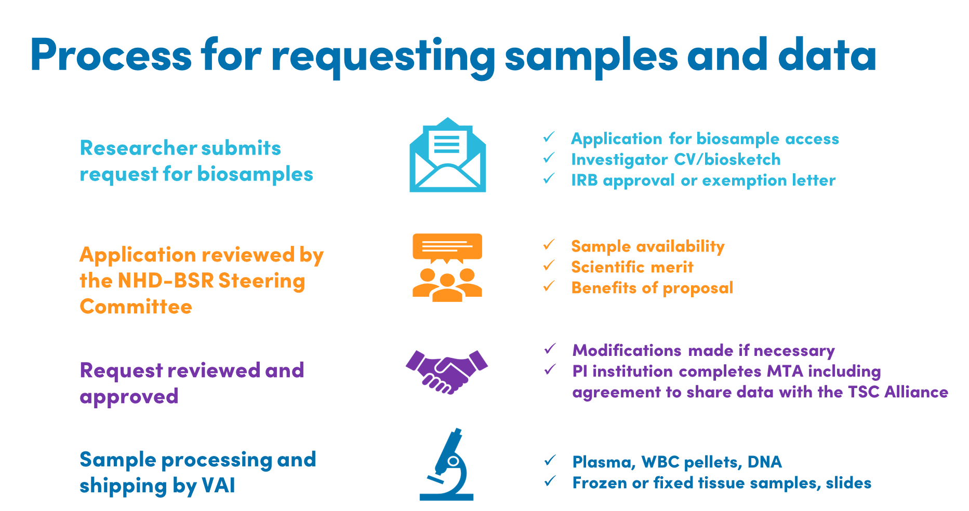

Data Sharing Statement
Along with the biosamples, you will be entitled to receive any data generated by other investigators using these samples. In return, you are required to share data generated on each sample with the TSC Biosample Repository. Data can be embargoed for a period to be defined in the Material Transfer Agreement to provide time to publish, protect intellectual property, etc. You can describe your data sharing plan in the application below.
☐ Please check here to acknowledge that you have read and understand the data sharing statement.

Application Form

Principal Investigator Information

First Name: | Middle Name: | Last Name:
Salutation: | Degree(s): | Title:
Phone: | Alt. Phone: | Fax:
Email: | CC Email:

Mailing Address

Institution: | Department:
Address Line 1: | Address Line 2:
City: | State: | Zip:
Country: | Institution’s Federal Congressional District:
Funding source(s) to support the proposed work, including specific award numbers:

Date of Request:
PI Demographics (Optional)

This information is optional but is vital to track the TSC Alliance’s progress toward improving the equity, diversity, and inclusion of our research programs. The information will not be disclosed or disseminated to anyone outside of the Steering Committee and the TSC Alliance. The information will not be used to decide whether a specific application is approved or not.

Gender

☐Male ☐Female ☐Prefer not to disclose ☐Prefer to self-describe: Click or tap here to enter text.

Race

☐American Indian or Alaska Native ☐Asian ☐Black or African American

☐Native Hawaiian or Other Pacific Islander ☐White or Caucasian ☐Prefer not to disclose

☐Prefer to self-describe: Click or tap here to enter text.

Ethnicity

☐Hispanic or Latinx ☐Not Hispanic or Latinx ☐Prefer not to disclose

☐Prefer to self-describe: Click or tap here to enter text.

Shipping Information

Lab contact/Recipient:

☐ Check if the same as PI Information

First Name: | Middle Name: | Last Name:
Salutation: | Degree(s): | Title:
Phone: | Alt. Phone: | Fax:
Email: | CC Email:

Shipping Address

☐ Check if the same as PI Information

Institution: | Department:
Address Line 1: | Address Line 2:
City: | State: | Zip:
Country:

Study Information

Study Title:

Specific Aims:

Long-term study objectives (please include potential impact to TSC community):

Overall Project Summary (please include experimental design and methods):

Justification for Numbers:

Example: volume or quantity of samples requested. Please include statistical power analysis, if applicable.

How soon will you use the samples once received?:

Data Sharing - Please describe the specific data elements that will be provided back to the TSC Biosample Repository for each sample analyzed:

Data Sharing – Please describe any other ways you plan to share the data, results, and resources that are generated:

Sample Request Information: Donor Details

Donor Demographics

Biological Sex: ☐ Male ☐ Female ☐ Either

Race: ☐ Any

☐ American Indian or Alaska Native ☐ Asian ☐ Black or African American

☐ Native Hawaiian or Other Pacific Islander ☐ White or Caucasian ☐ Multi-racial

Age Range:

Minimum: Maximum:

Donor Clinical History (please list any inclusion and exclusion requirements):

Total Number of Donors Requested:

Sample Preparation Details
Blood Prep Type
☐ Plasma Volume: ☐mL ☐µL
☐ White Blood Cell Pellets Number of cells per sample: Click or tap here to enter text.

☐ Other (please explain):

Nucleic Acid (please specify source)

☐ DNA from Blood ☐ DNA from Buccal Swabs ☐ DNA from Tissue

Minimum quantity: Maximum quantity:

Minimum concentration: Maximum concentration:

Minimum volume: ☐mL ☐µL

Tissue (select all that apply; please specify tissue origin in ‘Other Preparation Details’ below)

☐ Frozen

☐ FFPE

☐ Tissue Curls Thickness: # of curls:

☐ Glass Slides # of unstained slides: # H&E stained slides:

Other Preparation Details
Please describe, including specifics as appropriate:

Any other considerations we should be aware of?

Natural History Database (NHD) Data
Will your project also use data stored in the NHD?

☐ YES
☐ NO

If YES, please fill out the NHD DATA REQUEST FORM along with this APPLICATION FOR BIOSAMPLE ACCESS.

