**Science and Medical Programs**

**TSC Alliance® Research Programs**

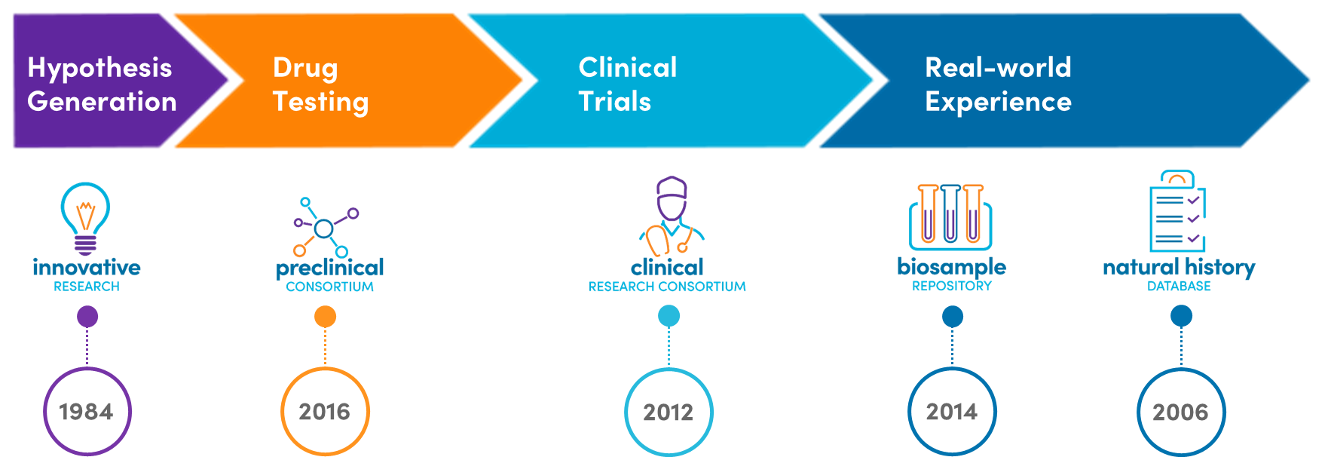

The TSC Alliance stimulates, coordinates, and drives research toward a cure for TSC while improving the lives of those affected. Since 1984, the **TSC Alliance has invested more than $34 million into TSC research projects** through grants and contracts:

* $20.1 million in research grants
* $4.8 million into the Natural History Database and Biosample Repository
* $7.9 million into the Preclinical Research Consortium
* $1.3 million into the Clinical Research Consortium

**Innovative Research**

*Research Grants Program* - Through the TSC Alliance research grants program, applications can be submitted for postdoctoral fellowships or research grants. Since 2020, research grants have been limited to early-stage investigators as defined by the National Institutes of Health (NIH). Grants are reviewed in a three-step process: (1) all grant applications are reviewed by a committee comprised of scientists knowledgeable about the topic area for scientific merit and of adults affected by TSC for potential impact on the lives of those affected by TSC; (2) the Science and Medical Committee of the Board of Directors evaluates the grant review committee’s recommendations and the relevance of the applications to the TSC Alliance’s funding priorities; and (3) the Board of Directors then reviews the recommendations of the Science and Medical Committee and makes final approval for funding. For a complete list of currently funded projects and an archive of past awardees, please visit tscalliance.org/grants.

*Innovation Workshop* - In addition to specific collaborative projects detailed above, the TSC Alliance stimulates collaboration and innovation through convening experts and stakeholders within and outside the TSC field. In 2020, the TSC Alliance introduced the concept of an *ad hoc* innovation workshop focused on a specific research gap or opportunity. The first innovation workshop topic was *newborn screening,* held using Zoom and Powernoodle in late 2020 and culminating in a Zoom meeting on January 29, 2021. Participants included 20 researchers with TSC expertise; 19 researchers with newborn screening experience from CDC, NIH, and academic laboratories; and five representatives of non-TSC advocacy organizations with newborn screening experience. Based on recommendations from the workshop, the TSC Alliance announced a funding opportunity and, following peer review of applications by experts in TSC and screening research, the TSC Alliance awarded funding to the following projects:

* Michael Gelb, PhD: “Proteomic assay for newborn screening of tuberous sclerosis complex” (University of Washington)
* Carmen Priolo, MD, PhD: “Application of glycomics to identify early biomarkers of TSC” (Brigham and Women’s Hospital)

These projects are the first steps in assay development. These exciting strides forward will serve as a launching pad for future work to develop and validate a specific assay and ready it for newborn screening toward the ultimate goal of earlier TSC diagnosis and treatment.

Thanks to a recent gift from the Ramesh and Kalpana Bhatia Family Foundation, the TSC Alliance has created Anya’s Accelerator to focus on furthering translational research on TAND. As a result of this gift, the TSC Alliance will host an Innovation Workshop in April 2023 focused on identifying biomarkers and predictors of specific aspects of TAND through collaborative and inclusive analysis of existing biosamples and data via metabolomic, genetic (RNA-seq), or other methods. We have confirmed attendance of 20-plus TSC experts ranging from scientists, clinicians, researchers, community members, industry, and NIH.

*Research Conferences* - The TSC Alliance sponsors a research conference every two years. Due to the ongoing pandemic, the 2021 conference was held virtually with great success. The 2023 International TSC Research Conference will be held September 7-9, 2023, at the Omni Shoreham Hotel in Washington, DC. The goals of this conference are to inspire new research directions by exposing trainees and researchers from outside the field and belonging to groups underrepresented in research to the latest research developments in TSC or other relevant fields and stimulate collaborative research to address unmet medical needs of those affected by TSC as well as related disorders, including epilepsy, autism, lymphangioleiomyomatosis (LAM), and rare diseases with overlapping phenotypes. The event will include a half-day TSC Early Career Research Symposium the morning before the main conference begins, and we plan to increase the diversity of early-career attendees by reserving half of the travel awards for scientists who belong to underrepresented groups in research, including scientists without data to present on TSC-related work. Scientific co-chairs of the research conference are Drs. Shafali Jeste and Rebecca Ihrie. The conference will assemble TSC experts together with non-TSC-focused researchers in an environment conducive to sharing data, networking, and building opportunities for future collaboration. The conference will utilize breakout sessions to discuss relevant interdisciplinary topics and employ platform sessions specifically to facilitate cross-specialty understanding by combining in the same session—to the extent reasonably possible—basic, translational, and clinical research data.

**Preclinical Consortium**

Translational research takes early discoveries and facilitates its entry into clinical care through coordinated and directed research to evaluate the effectiveness and safety of candidate therapeutics. A key component of this research is conducted in the TSC Preclinical Consortium, which encourages collaboration between a multidisciplinary team of researchers, including clinical researchers. The consortium facilitates drug testing in cell and animal models of TSC. Those compounds that prove efficacious and safe are referred to the TSC Clinical Research Consortium to consider for clinical testing. A goal of the Preclinical Consortium is to advance at least two candidate compounds into clinical trials by 2025.

Through donations from the community, *TSC2* models of tumors and *TSC1* epilepsy models have been established suitable for drug testing (screening). In 2022-2023, the consortium is currently characterizing a *TSC1* mouse model with autism-related behaviors and a *TSC2* mouse model of epilepsy in collaboration with Mustafa Sahin, MD, PhD. In addition, a model for LAM will be added in 2023 in collaboration with The LAM Foundation and Nishant Gupta, MD.

Experiments are carried out at partnering research institutions, including contract research laboratories, to ensure consistency in testing, data acquisition and interpretation. Epilepsy studies are conducted at PsychoGenics (US), and the tumor graft model is conducted at Porsolt (France). The TSC Alliance partners with the Van Andel Research Institute, a non-profit research organization, to maintain a colony of Tsc2+/- AJ mice and to breed mouse strains for TAND and *Tsc2*-driven epilepsy.

These resources are vital to the consortium for TSC research and recruiting industry and academic partners to TSC. The consortium continues to add new members with a goal to increase the diversity of mechanisms and likelihood for some of the technology to advance to clinical testing.

This year, two new industry members joined the consortium with a total of   
10 active industry members at the end of the year. The consortium tested seven unique compounds in 2022, raising the total tested to 63 since 2016. Many compounds will enter preclinical testing, though only some will advance to clinical testing due to lack of efficacy and safety.

Excitingly, there are partners seeking clinical trials for their compounds in 2023-2024. Two have or are conducting “FDA-enabling studies” required to establish the safety of the drugs and one partner is seeking FDA regulatory submission of an Investigational New Drug application (IND) for the conduct of a clinical trial in TSC-associated epilepsy. With time and continued investment, more of the 63 tested compounds will likely move forward into FDA-enabling studies, INDs, and clinical trials.

The team continues to capitalize on the momentum to advance candidate compounds to clinical testing. The horizon for preclinical research in 2023 is bright. Looking forward, we have already contracted nine experiments with three companies to evaluate their drugs in preclinical models and are actively cultivating three new industry members.

Lastly, the team is working hard to increase donations that support the TSC Preclinical Consortium. This funding allows us to increase the diversity of TSC models and assays, attract new investigators and industry partners, and for testing compound nominations made by investigators.

**TSC Biosample Repository and Natural History Database**

The TSC Alliance built the TSC Biosample Repository to accelerate research into why TSC is so variable among individuals and how we might determine which individuals respond better or poorly to certain treatments. Samples in the repository are linked to detailed clinical data in our TSC Natural History Database and are available to qualified researchers worldwide. As of December 1, 2022, the Natural History Database contained 2,546 participants enrolled across 21 TSC clinic sites or by the TSC Alliance.

Samples are housed at and distributed from the Van Andel Institute in Grand Rapids, Michigan, under control of the TSC Alliance. Research projects utilizing biosamples are expected to lead to new hypotheses regarding biomarkers, mechanisms for new treatment approaches, risk factors, or genetic modifiers. These discoveries could make clinical trials more efficient and lead to drug development or new directions of research and larger projects funded by the National Institutes of Health (NIH), Department of Defense’s Tuberous Sclerosis Complex Research Program (TSCRP), or other sources.

The Biosample Repository continues to add diversity in types of samples. Ultimately, this valuable resource will help lead the way for predictive and personalized care. As of December 1, 2022, the Biosample Repository has acquired 2,297 blood, buccal (cheek) swab, or tissue samples. Our mobile phlebotomy initiative, with generous support from Lorne Waxlax, enables anyone with TSC to participate in the Biosample Repository regardless of where they receive medical care. To date, we have acquired356 blood samples via mobile phlebotomy. We are excited to enable our constituents to participate from anywhere in the US or Canada.

**Key:** NHD: Natural History Database; RDCRN: Rare Disease Clinical Research Network (NIH-funded research network of the Developmental Synaptopathies Consortium (DSC) including a focus on TSC); PREVeNT: Preventing Epilepsy Using Vigabatrin in Infants with Tuberous Sclerosis Complex trial; TACERN: Tuberous Sclerosis Complex Autism Center of Excellence Network Early Biomarkers of Autism in Infants with TSC; TSC-STEPS: Stopping TSC Onset and Progression 2B: Sirolimus TSC Epilepsy Prevention Study; Mobile: mobile samples from the Waxlax Biosample Collection Initiative; MBTB: Maryland Brain and Tissue Bank samples; Control: non-TSC samples.

Since inception, portions of 1,897 samples have been distributed to 40 distinct researchers for 47 distinct projects. TSC Alliance also sponsors funding of scientifically reviewed applications for Biosample Seed Grants to increase the utilization of our current inventory and advance scientific discoveries.

*Whole Genome Sequencing (WGS)* - Because TSC affects everyone differently, many researchers have hypothesized the existence of “modifier genes” outside of the *TSC1* and *TSC2* genes that could modify disease progression or severity. Studies to search for modifier genes require hundreds to thousands of DNA samples from unique individuals and costly sequencing of each person’s DNA. WGS is a type of next-generation sequencing and is currently the most comprehensive method to characterize a person’s full genetic code. The main difference between standard sequencing methods and WGS is the amount of data generated. WGS is very high throughput. Whereas traditional sequencing may sequence a single DNA fragment at a time, WGS can process hundreds to thousands of fragments at one time. Additionally, WGS has an improved ability to detect DNA changes that occur infrequently or that may not be able to be detected via traditional methods, thus allowing researchers to discover new DNA changes (also called variants). WGS is an important step toward understanding the relationship between genetic variants and their impact on disease. Rather than having many researchers at different institutions undertake this type of sequencing, the TSC Alliance can accelerate this process by coordinating and funding WGS on hundreds of DNA samples and sharing those data with multiple researchers.

Genetic results are one of the most requested pieces of data from the Natural History Database. We have completed or have in-progress WGS on 68 samples and plan to grow this project to complete WGS on 500 samples and offer the data to TSC researchers to better understand the variability observed in people affected by TSC, which may lead to predictive and personalized care.

This initiative also supports clinical validation of variants found via WGS in either the *TSC1* or *TSC2* gene at GeneDx, so genetic results can be offered back to participants along with a genetic counseling session free of charge to the family to help them better understand their unique TSC diagnosis and provide valuable information for future decision making such as family planning. Our current genetic counseling partner is Kate Richardson, MS, CGC, at University of Texas Health Science Center at Houston.

Self-Report Portal - In December 2021, the TSC Alliance added the TSC Self-Report Portal (SRP) to the TSC Natural History Database. This portal permits the collection of patient-reported outcomes (PROs). PROs are a report of the patients’ perspectives about the impact of disease and treatment on their health status, for example quality of life and symptoms, without the interpretation of a clinician or anyone else. Through the SRP, the TSC Alliance is collecting information on how TSC affects individuals and families, which will complement medical data in the Natural History Database. The purpose of this initiative is to help the TSC Alliance and TSC researchers better understand the perspective of those affected by TSC to develop tools to measure improvement in areas most important to the TSC community. Eventually, these measurements can be used to identify endpoints for clinical trials and evidence-based guidelines for treatment.

One of the most impactful aspects of TSC on the quality of life for people living with TSC is TAND—TSC-associated neuropsychiatric disorders. Through collaboration with the TANDem project (Empowering Families through Technology: a mobile-health project to reduce the TAND identification and treatment gap), the self-quantified TAND checklist (TAND-SQ) has been incorporated into the SRP, and 67 individuals have completed the TAND-SQ in the SRP to date. The TSC Alliance is helping the TANDem project team validate the utility of the TAND-SQ for future use in a mobile application. (You can read more about the TANDem project at [tandconsortium.org/about/](https://tandconsortium.org/about/)). For many TAND symptoms, there are currently no objective outcome measurements or a way to quantify severity. This initiative is designed to help us better understand TAND and how to treat it by learning directly from those affected by TSC or their caregivers. A new SRP questionnaire will be added focusing on TAND and epilepsy from the caregiver perspective in early 2023.

**Clinical Research Consortium**

In 2012, the TSC Alliance helped create the TSC Clinical Research Consortium in partnership with investigators running clinical studies to ensure clinical research in TSC is as efficient and effective as possible. Since then, TSC Clinical Research Consortium investigators have been awarded more than $39 million by the NIH and Food and Drug Administration (FDA) through competitive grant processes. TSC Alliance personnel serve on the leadership team for the consortium, actively track enrollment, and raise community awareness to help identify potential participants for clinical studies. The TSC Alliance also provides supplemental financial support to accelerate or expand NIH-funded studies.

*TSC-STEPS* (Stopping TSC Onset and Progression 2B: Sirolimus TSC Epilepsy Prevention Study) is currently enrolling infants. This trial is the second stage of the STOP-2 (Stopping TSC Onset and Progression 2) trial and follows a similar trial structure as the PREVeNT trial described below. The TSC Alliance has contributed $200,000 to enable TSC-STEPS to be expanded to additional sites across the country. Fourteen infants have been enrolled so far and four biospecimens collected for the TSC Biosample Repository. For more information about this ongoing and currently enrolling study, please search for [NCT05104983 at clinicaltrials.gov.](https://www.clinicaltrials.gov/ct2/show/NCT05104983)

*The PREVeNT trial*—Preventing Epilepsy using Vigabatrin in Infants with TSC—is the first preventative trial in the United States for any form of epilepsy. The trial has completed enrollment, and we expect results in the first quarter of 2023. In the PREVeNT trial, infants with TSC receive regular EEG monitoring and those who develop EEG abnormalities are placed on either vigabatrin (supplied by Lundbeck) or a placebo. Any infant who subsequently develops clinical seizures is immediately placed on standard treatment. This trial will determine whether treatment with vigabatrin prior to the onset of clinical seizures in TSC is beneficial to children’s developmental and neurologic outcomes. In addition to promoting awareness of the trial among the TSC community to enhance enrollment, the TSC Alliance is collecting blood samples from participants in PREVeNT for the Biosample Repository.

The TSC Alliance is also providing supplemental funding and collecting blood samples for the *Developmental Synaptopathies Consortium (DSC)*, an NIH-funded project which includes studies of TSC and the related rare disorders Phelan-McDermid Syndrome and PTEN Hamartoma Syndrome. These three rare diseases seem to affect certain shared pathways influencing the development of brain connections, or synapses. The goal of this research study is to learn more about children and young adults who have TSC and autism spectrum disorder (ASD), TSC with intellectual disability (ID), or TSC with both. Researchers in this study are trying to find earlier signs of ASD and ID to gain a better understanding of ASD/ID in individuals with TSC and enable effective treatments and interventions for ASD/ID to be found. The DSC was renewed in 2019 for a second five-year funding period. The TSC Alliance funds a portion of clinical research coordinators’ salaries at five sites and in 2021 began funding a two-year clinical research TSC-DSC fellowship.

Felix Chan, PhD, was the 2021-2023 awardee for this fellowship and has recently changed institutions from Brown University to Aston University in Birmingham, England. The two-year fellowship is funded by the TSC Alliance and utilizes the extensive clinical data and biological samples of the DSC. The intent of the fellowship is to offer early-stage investigators the research environment and training they need to launch an academic career in translational research beneficial to TSC research and individuals living with TSC. Dr. Chan’s fellowship project, titled “Lysine metabolism in tuberous sclerosis complex,” seeks to identify whether or not lysine metabolites in the blood are a biomarker of seizure severity or response to the drug everolimus in individuals with TSC.

**International TSC Clinical Consensus Guidelines**

In August 2021, two new publications were published in *Pediatric Neurology*, “*Updated International TSC Diagnostic Criteria and Surveillance and Management Recommendations”* and *“Beyond the Guidelines: How We Can Improve Healthcare for People with TSC Around the world*.” The new papers are available from <https://www.tscalliance.org/healthcare-professionals/key-medical-publications/> and provide the first significant updates to the international guidelines since 2013 because of new medications and advances in treatments. To address the changes, a working group led by Darcy A. Krueger, MD, PhD, of Cincinnati Children's Hospital Medical Center, and Hope Northrup, MD, McGovern Medical School, University of Texas Health Science Center at Houston, included 80 participants from 16 countries.

**TSC Centers of Excellence and TSC Clinics**

The TSC Alliance supports the vital role that coordinated and integrated healthcare by providers with expertise in TSC can play in improving the lives of individuals with TSC. In December 2020, the TSC Alliance Board of Directors approved new clinic structure and expertise requirements for recognition by the TSC Alliance as a TSC Center of Excellence or TSC Clinic. The new clinic guidelines include evaluating the quality of clinical care based on standards of care metrics and the “patient experience” through the *TSC Clinic Patient and Family Experience of Care Survey.* TSC Clinics in the United States were asked to report metrics aimed at assessing delivery of care according to the 2021 Clinical Consensus Guidelines in seven clinical categories, including TAND. Data were received in late 2021 and analyzed in early 2022.

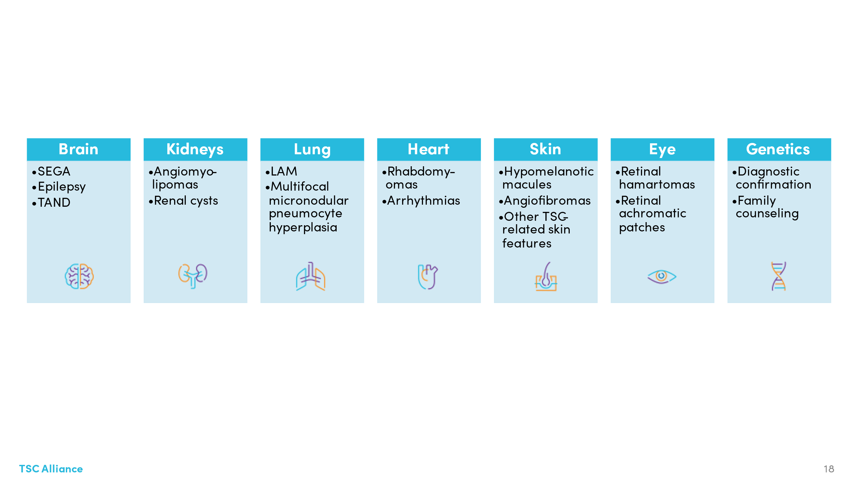

While some metrics were consistent from clinic to clinic, we found wide variability in others. We also found some were very difficult to pull directly from electronic medical records, requiring manual effort not achievable by all clinic sites because of the staff time required.

We are taking two approaches to improve this process. One is to decrease the number of metrics collected and focus, as a starting place, on three to five metrics which are most variable and most important for TSC care. The second is to explore a system, Dock Health, which can integrate with electronic health systems to streamline the collection of key data points.

**TSC Navigator**

The TSC Navigator launched October 14, 2021, and has received more than 3,100 hits between launch and December 15, 2022. TSC Navigator is an easy to use, interactive online tool to help guide individuals and families through the complexities of TSC across the lifespan, proactively manage their care, and live their fullest lives. Users can access information based on the age of one’s diagnosis, such as prenatal, childhood, or adult, to help determine which steps will help empower them throughout their individual journeys. Regardless of age, TSC Navigator also helps individuals with TSC and their caregivers face complex situations, overcome access issues, and address insurance barriers. In addition, four companion Navigation Guides were updated in 2022 covering early years, school age years, transition years, and adult years of TSC.

**Community-Focused Research and Clinical Development Priorities** – The TSC Alliance convened an externally-led patient-focused drug development meeting (PFDD) with the FDA at the Hyatt Regency on Capitol Hill in Washington, DC, on June 21, 2017. This session provided the opportunity for individuals affected by TSC and caregivers of dependent adults or children with TSC to communicate their perspectives on living with TSC to help the FDA understand the context in which regulatory decisions are made for new drugs. The TSC Alliance submitted the *Voice of the Patient* report resulting from this meeting to the FDA in October 2017. The report and recordings of the meeting are available at tscalliance.org/pfdd.

**International Scientific Advisory Board (ISAB)** – The TSC Alliance science and medical program is advised by a group of distinguished and dedicated TSC researchers. These individuals serve a three-year term and are nominated and approved by members of the Science & Medical Committee. The ISAB plays an important role planning conferences, advising on research priorities and strategy, and reviewing proposals for funding of research by the TSC Alliance.

**Professional Advisory Board (PAB)** – The Professional Advisory Board is comprised of healthcare professionals with expertise in the various clinical manifestations of TSC. These individuals serve a renewable three-year uncompensated term and are nominated by the Science and Medical Committee. The PAB serves as a vital resource for medical expertise to develop and review health-related information provided by the TSC Alliance.

**TSC1/2 Variation Database** – The TSC1/2 Variation Database was developed by the late Dr. Sue Povey and Dr. Rosemary Ekong at University College London. This database serves as a resource for clinicians, molecular diagnostic laboratories and researchers worldwide. Though the TSC Alliance funding for this project has completed, the database is still maintained as a clinical and research resource.

**Exhibits at Professional Society Meetings** – COVID-19 prevented the TSC Alliance from exhibiting at in-person meetings until December of 2021, but we have since resumed exhibits at selected in-person professional society meetings with the goal of providing information about TSC to conference participants and educating health care professionals and researchers about TSC. The largest TSC Alliance presence is at the American Epilepsy Society annual meeting, which has the largest attendance of neurologists and bench researchers working on TSC; it also attracts international clinicians and researchers. TSC Alliance typically exhibits at the American Thoracic Society (ATS) to connect with LAM clinicians and researchers. TSC Alliance staff typically attend each year’s Child Neurology Society meeting to network with clinicians and industry partners. When drafting the annual budget, TSC Alliance staff look for opportunities to engage with attendees at various specialty meetings including autism, nephrology, dermatology, neuroscience or cancer research, pediatrics, and advanced practice providers (nurse practitioners and physician assistants).

**Partnerships with other nonprofit organizations** – The TSC Alliance works with other non-profit organizations with common interests to help bolster research and support efforts across a wide span of activities. One such partnership is the Epilepsy Leadership Council, a coalition that focuses on epilepsy research, care, services, education, and advocacy efforts.

Two public-private partnerships involving the TSC Alliance are the Interagency Collaborative to Advance Research in Epilepsy (ICARE) and the Interagency Autism Coordinating Committee (IACC), both of which include nonprofit and patient advocacy groups and federal government representatives from the National Institutes of Health, Centers for Disease Control, and other relevant agencies.

The LAM Foundation and TSC Alliance co-hosted the 2021 international research conference virtually. Each year the organizations share information on grant applications to consider whether co-funding of research grants is an opportunity, which we have done multiple times in the past. The organizations have also collaborated to include individuals with sporadic LAM in the TSC Natural History Database COVID-19 sub study.

As a leading rare disease patient advocacy organization, TSC Alliance is often asked by umbrella rare disease organizations, including Global Genes and the Chan-Zuckerberg Initiative, to share our experiences with new, smaller organizations. This also benefits the TSC Alliance by introducing us to new industry partners and other larger non-profits, which has led to new collaborations.

The TSC Alliance gains insight and provides our voice by partnering with like organizations in overall efforts to increase awareness of rare diseases like TSC. The TSC Alliance is a member of the Rare Epilepsies Network, a project which developed a joint registry of individuals affected by rare diseases that cause epilepsy, and AGENDA (Alliance for Genetic Etiologies of Neurodevelopmental Disorders and Autism), a partnership of research and advocacy organizations focused on improving outcomes of individuals with all forms of autism by fostering a genetics-first approach to autism science. We partner with the Child Neurology Foundation and other organizations as Governance Committee members of the Infantile Spasms Action Network to sponsor Infantile Spasms Awareness Week annually during the first week of December and in 2020 were founding members of the Seizure Action Plan Coalition along with the Dravet Syndrome Foundation and LGS Foundation. We are proud members of the National Organization of Rare Diseases (NORD), Global Genes Foundation Alliance, Research!America and the Health Research Alliance. Additionally, the TSC Alliances frequently meets with other rare disease organizations to provide insights and guidance into research program development and management.

**Other Sources of TSC Research Funding available** – This money goes directly to researchers, not to or through the TSC Alliance.

* Tuberous Sclerosis Complex Research Program (TSCRP) of the Congressionally Directed Medical Research Program (CDMRP) administered by the Department of Defense (DOD) has supported $105 million in TSC research since 2002.
* National Institutes of Health (NIH) funding has supported approximately $412 million in TSC research since 2002. The TSC Alliance has conversations annually with senior personnel in the following institutes and offices at NIH: NCATS (including the Office of Rare Disease Research), NIAMS, NHLBI, NCI, NIDDK, NINDS, NICHD, and NIMH. Additionally, program officers from these institutes meet bi-annually with TSC Alliance staff and TSCRP staff in a “Trans-NIH meeting” to share TSC research being supported by each organization and to discuss ways in which they can work together to stimulate and support TSC research initiatives. In March 2015, NINDS, TSC Alliance, and TSCRP led a workshop of clinical, basic, and industry researchers to update the 10-year Research Plan for TSC. The outcomes of this workshop continue to influence the priorities for investment of precious research dollars by the TSC Alliance, NIH, and TSCRP.
* There are several non-profit organizations that also support TSC-related research grant awards. They include The LAM Foundation, AES, CURE Epilepsy, the PKD Foundation, and Autism Speaks.